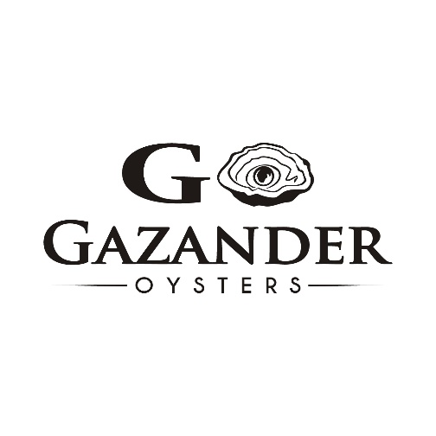
Gazander Oysters Current Situation
Well, what a couple of weeks it’s been. It's been a rapidly evolving situation and still is.
Here’s the update to what is happening in the Oyster industry and our business and information about Vp and the illness it may cause.
Currently our harvesting area and bay system is closed for any harvest of oysters for consumption as midday Tuesday 16th November. This has been taken as a precautionary manner due to increase cases of illness due to vibrio parahaemolyticus.

Do you have any frozen Oysters?
A recall on all oysters bought from 4th September is in place. This is on whole live product which none of our customers should have at this date in time as they are well outside of shelf life time frames. All whole live product was voluntarily recalled, returned and destroyed where necessary. If you have any oyster in freezer at this in point do not consume but please do not dispose of as yet.
We are waiting on further information from FSANZ and SA Health as to how this is dealt with.
211119 – COFFIN BAY OYSTERS RECALLED.pdf

What is Vibrio?
Vibrio parahaemolyticus, or “Vp’ as we refer to, is a bacterium that exist naturally in the water environment and for some reason it has been at much higher levels in South Australia this year. The oysters being filter feeders filter it in when they feed, one oyster may filter it in, and another may not.
From our knowledge this Vp bacteria has been slowly making its way around the world through oceans currents and now here in South Australia at higher levels.
Some studies and theories are related to abnormal climatic events involving warm oceanic waters in ocean currents. Further studies are needed to ascertain this.
://journals.asm.org/doi/10.1128/msystems.01161-20?permanently=true

Illness from vibrio
Food borne Vibrio parahaemolyticus infection causes symptoms of gastro, including watery diarrhoea, abdominal cramps, nausea, vomiting, fever, and headache, and usually occurs within 24 hours of eating the contaminated food.
Vulnerable people in our community are much more susceptible to Vp illness it seems – the SA Health Press release list some conditions that are considered higher risk.

211112 - GASTRO OUTBREAK LINKED TO RAW OYSTERS.pdf

What else do we know?
There seems to be high rate of Vp illness since September 1, 2021, and hence our shutdown, recall, to review practices and ensure ALL GROWERS are on the same page.
We had a very positive and proactive Coffin Bay grower meeting which was also attended by PIRSA staff this week and we are all 100% committed to find and fix any areas of weakness in our practices.
Currently at this point in time our scientists at SASQAP cannot detect any form of Vp in the water so it is very hard to control and collect data.
These bacteria borne illness is unprecedented in our 20 year of oyster growing – we have never seen anything like this before in South Australia.
Some data indicates oysters that are cooked above 65°C for a minimum of 2 minutes pose no risk for Vp illness. But please refer recall procedure at this stage and do not consume.

Our practices
Our harvesting practices are constantly evolving to ensure best practice for all work instruction and stringent cold chain procedures are continually being improved and implemented. However, we are required by Compliance order to conduct a full audit of our harvesting, processing, storage, and distribution of our systems to control vibrio bacteria which will be conducted by food safety officers from PIRSA.
Vibrio was an issue in Tasmania in past years and improvement of their practices which we are using as reference and guide has showed to be imperative in their control of Vp and they have had minimal cases in past years.

What next?
First we must implement food recall orders as issued by FSANZ.
After that we must provide evidence and documentation to auditors from PIRSA / food safety program that we have made necessary improvements to our Food Safety Arrangement, HACCP plan and monitoring form to have our compliance order removed before they will open the Harvesting areas again.
So far as growers we have been advised not to talk to the media and that we refer to our governing body, SAOGA for media comment. We are tackling this as an industry and determined to prove our practices are world class and as safe as possible. Find media statement from PIRSA and SAOGA link attached.

Media holding statement - SAGOA - Vp outbreak.docx.pdf
https://www.pir.sa.gov.au/alerts_news_events/news/ministerial_releases/coffin_bay_oyster_harvesting_area_closed

What does this mean for you?
This email is to give you as much information as possible and you are fully informed of all the key points involved.
We are truly sympathetic to anyone who have been ill. We take this situation very seriously.
Our next step is to be fully cooperative with SA Health, PIRSA, FSANZ and other government bodies involved to meet recall procedures, compliance orders and other necessary steps.

This has caused massive upheaval for our business and the whole oyster industry which may take a very long time to recover from. We apologize for any inconvenience and worry this may have caused our valued customers.
Thank you for your continued support in the past of Gazander oysters. It’s been a tough week and following last 7 years POMS spat crisis and the Covid effect on our markets this feels like a fairly big kick in the guts.
Thank you to all those that have been in contact so far with well wishes. It means a lot.

Carly and Thomo
Gazander Oysters

